Đề 4:

* Q1:

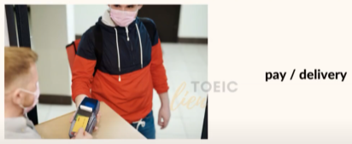

A man is paying for a delivery man with his credit card.

* Q2:

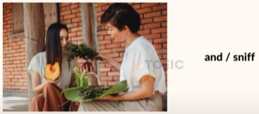

There are two women and one of them is sniffing the vegetables.

* Q3:

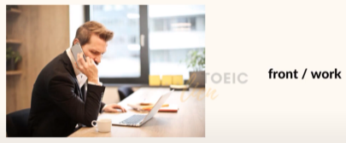

A man is sitting in front of the computer in the working office.

* Q4:

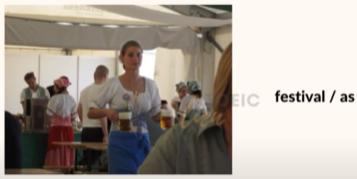

As the beer festival, people are drinking beers.

* Q5:

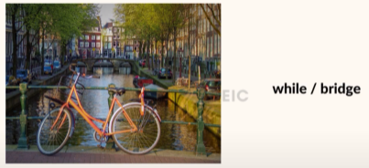

A bicycle is leaning against the bridge while there are no one here.